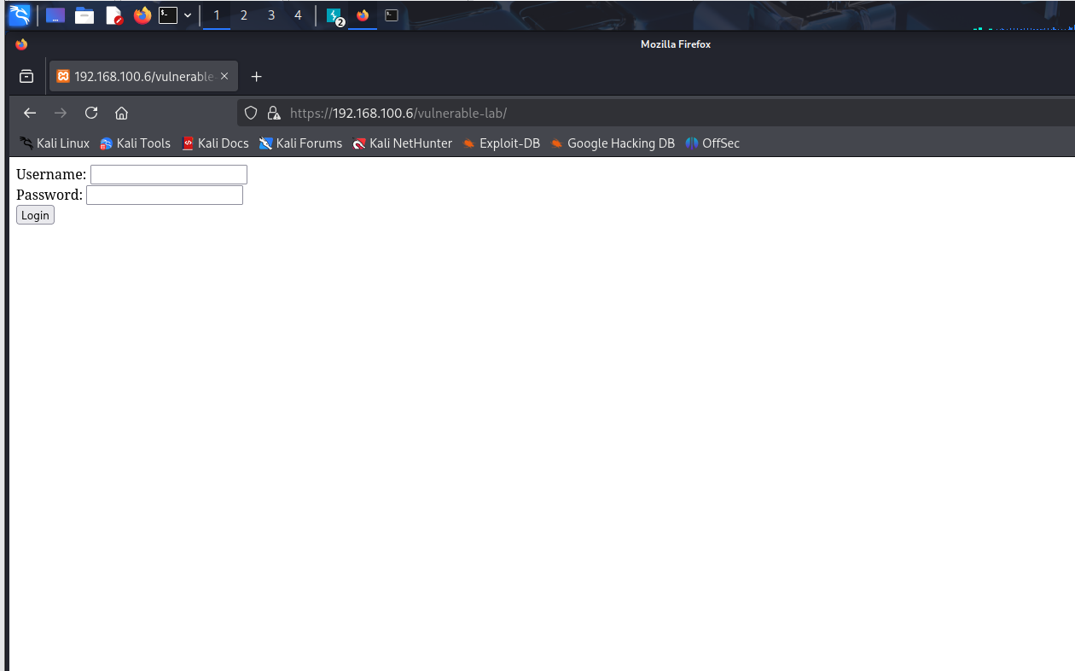
Adding simplest sql injection
……………………………………………………………………….
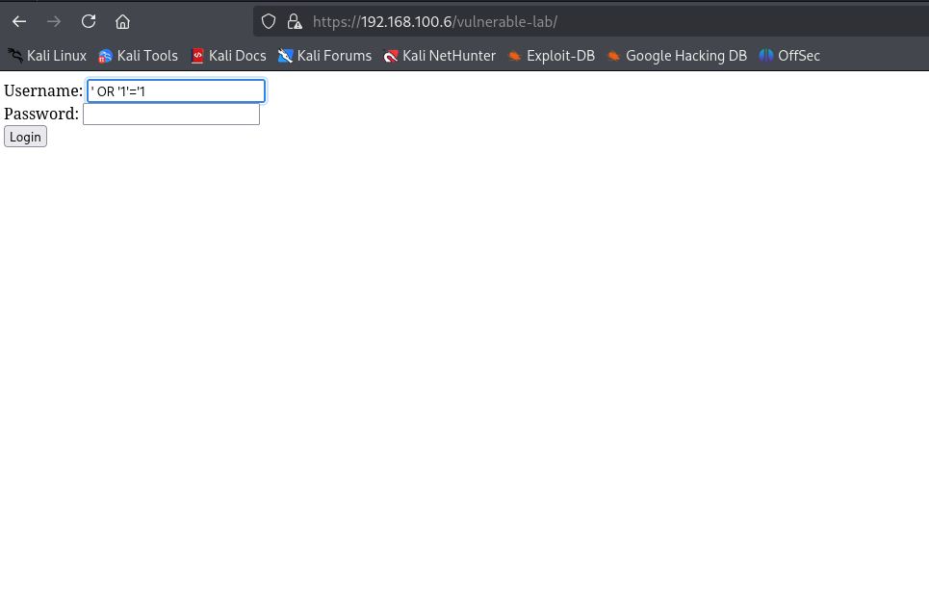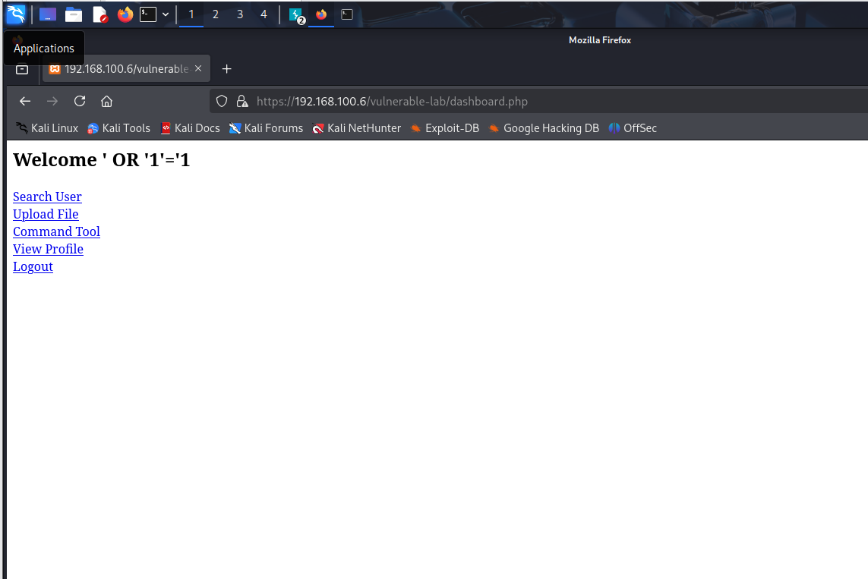
We have logged In successfuly
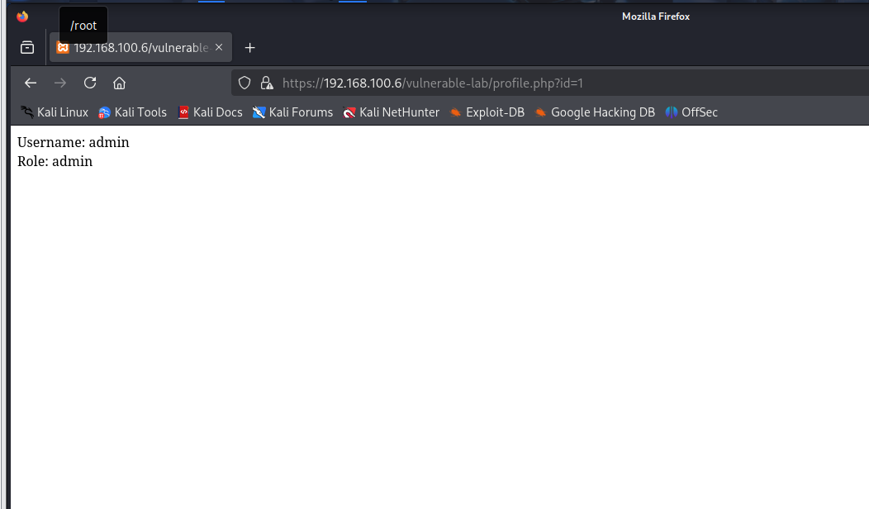
Here we checked the user in url it is showing the id=1 let us change the id .
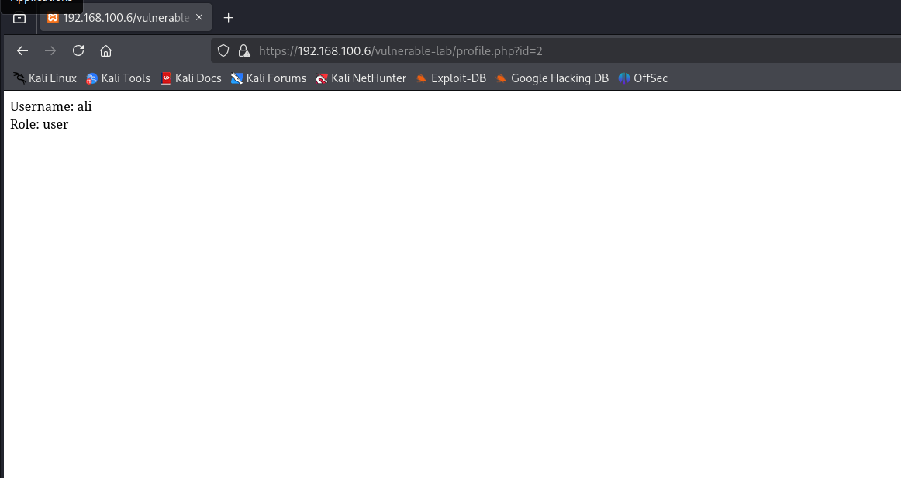
When we changed the id=2 it showed us another user.
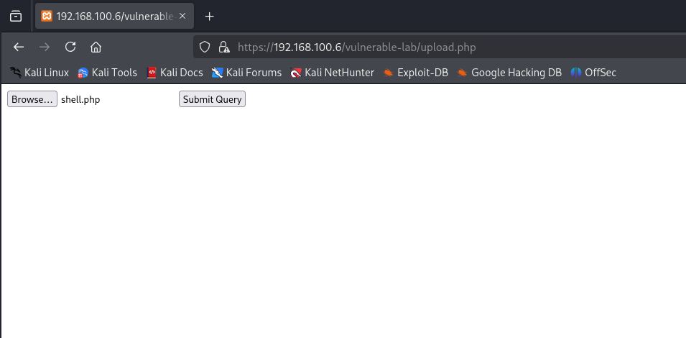now it is a file upload vulnerability .
- Create a php shell copy from the github payloadallthethings and uploiad the test.php file to it . and to trigger it add a netcat listener on kali .
- After it go to the uploads from url it will trigger the payload and you will get the reverse shell
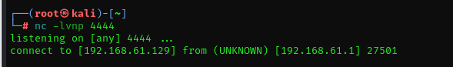

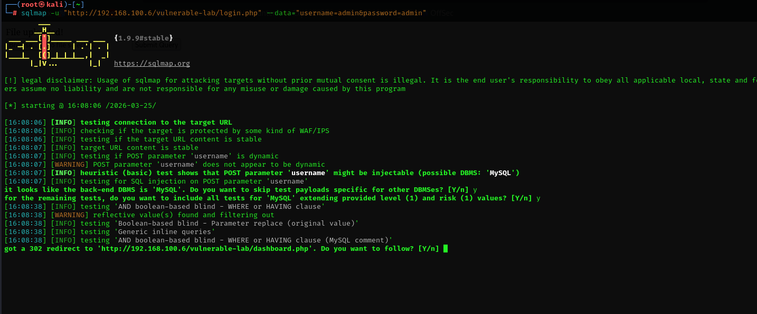

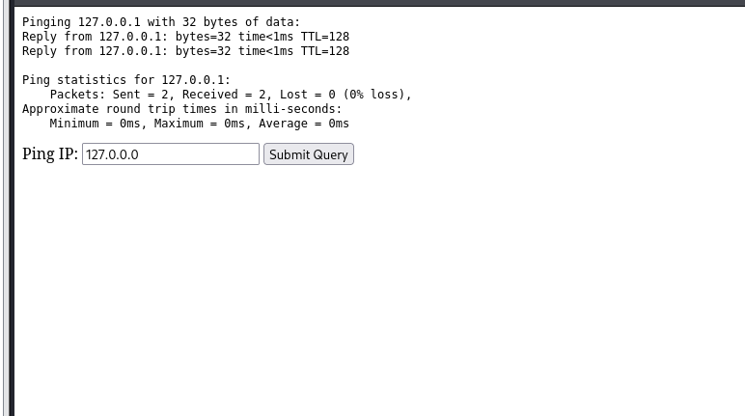
Now in ping enter an ip it will show result than add something more I entered you will get the device name too

